Age-expenditure profile option
Construction, evidence audit and top-down sensitivity
Internal methods note | 25 August 2026

Recommendation
Keep the separate shares aged 0-14 and 65+ as the baseline demographic treatment in the top-down time-series models. Use the age-expenditure profile index as a documented sensitivity and as a bridge to the bottom-up model. This is closest to normal research practice: aggregate time-series regressions generally use age shares or dependency ratios, while age-cost profiles are widely used in direct fiscal projection exercises. The profile option should not become the preferred top-down treatment until its current proxy relativities are replaced with Australian administrative age-cost profiles.

What the index measures
The index compresses the full age distribution into one measure of demographic spending pressure. For category k and age group a, let omega_k be the category's FY2024-25 expenditure share, r_ka its relative per-person age cost, and s_at the population share. The implemented index is A_t = sum_k omega_k [sum_a r_ka s_at / sum_a r_ka s_a,2025]. It is normalised to one in 2025, holds the category mix fixed, and changes only when population composition changes. It therefore represents an age-composition pressure, not total spending growth: wages, technology, policy, eligibility and excess cost growth remain elsewhere in the model.
The expenditure base is general-government spending classified by primary purpose. This is an approximate match to the broader top-down dependent variable, which also contains investment and income payable. The index excludes interest from the category weights because interest does not have a meaningful beneficiary age profile. Defence is retained with a flat age profile, so it affects the aggregate expenditure weights but not demographic change.

Where the weights come from

Category weights
The outer weights are observed FY2024-25 ABS Government Finance Statistics expenditure shares. They identify how much each purpose contributes to the aggregate index.
Category | FY2024-25 expenditure ($m) | Index weight (%)
Social Protection | 311,746 | 31.7
Health | 207,743 | 21.1
Education | 148,441 | 15.1
General public services excl interest | 64,031 | 6.5
Public order and safety | 52,774 | 5.4
Defence | 50,175 | 5.1
Transport | 47,156 | 4.8
Economic affairs | 46,365 | 4.7
Environmental Protection | 20,777 | 2.1
Recreation, culture and religion | 19,971 | 2.0
Housing and community amenities | 13,903 | 1.4

Within-category lifecycle weights
The inner weights describe relative exposure by age. Health rises strongly at older ages; education is concentrated among children and young adults; social protection is U-shaped but largest for older people; all other purposes are flat. These numerical relativities are transparent grouped proxies, not estimates recovered from Australian administrative microdata. Multiplying them by category expenditure shares produces the effective aggregate weights shown below.
Category | 0-14 | 15-34 | 35-54 | 55-64 | 65+
Defence | 1.00 | 1.00 | 1.00 | 1.0 | 1.0
Economic affairs | 1.00 | 1.00 | 1.00 | 1.0 | 1.0
Education | 1.00 | 0.35 | 0.05 | 0.0 | 0.0
Environmental Protection | 1.00 | 1.00 | 1.00 | 1.0 | 1.0
General public services excl interest | 1.00 | 1.00 | 1.00 | 1.0 | 1.0
Health | 0.65 | 0.75 | 0.90 | 1.3 | 3.0
Housing and community amenities | 1.00 | 1.00 | 1.00 | 1.0 | 1.0
Public order and safety | 1.00 | 1.00 | 1.00 | 1.0 | 1.0
Recreation, culture and religion | 1.00 | 1.00 | 1.00 | 1.0 | 1.0
Social Protection | 0.60 | 0.50 | 0.40 | 0.8 | 2.2
Transport | 1.00 | 1.00 | 1.00 | 1.0 | 1.0
Age group | Effective relative weight | 2025 population share (%) | 2025 index contribution (%)
0-14 | 1.20 | 17.4 | 20.8
15-34 | 0.83 | 27.6 | 22.8
35-54 | 0.66 | 26.3 | 17.3
55-64 | 0.85 | 11.2 | 9.5
65+ | 1.68 | 17.5 | 29.5
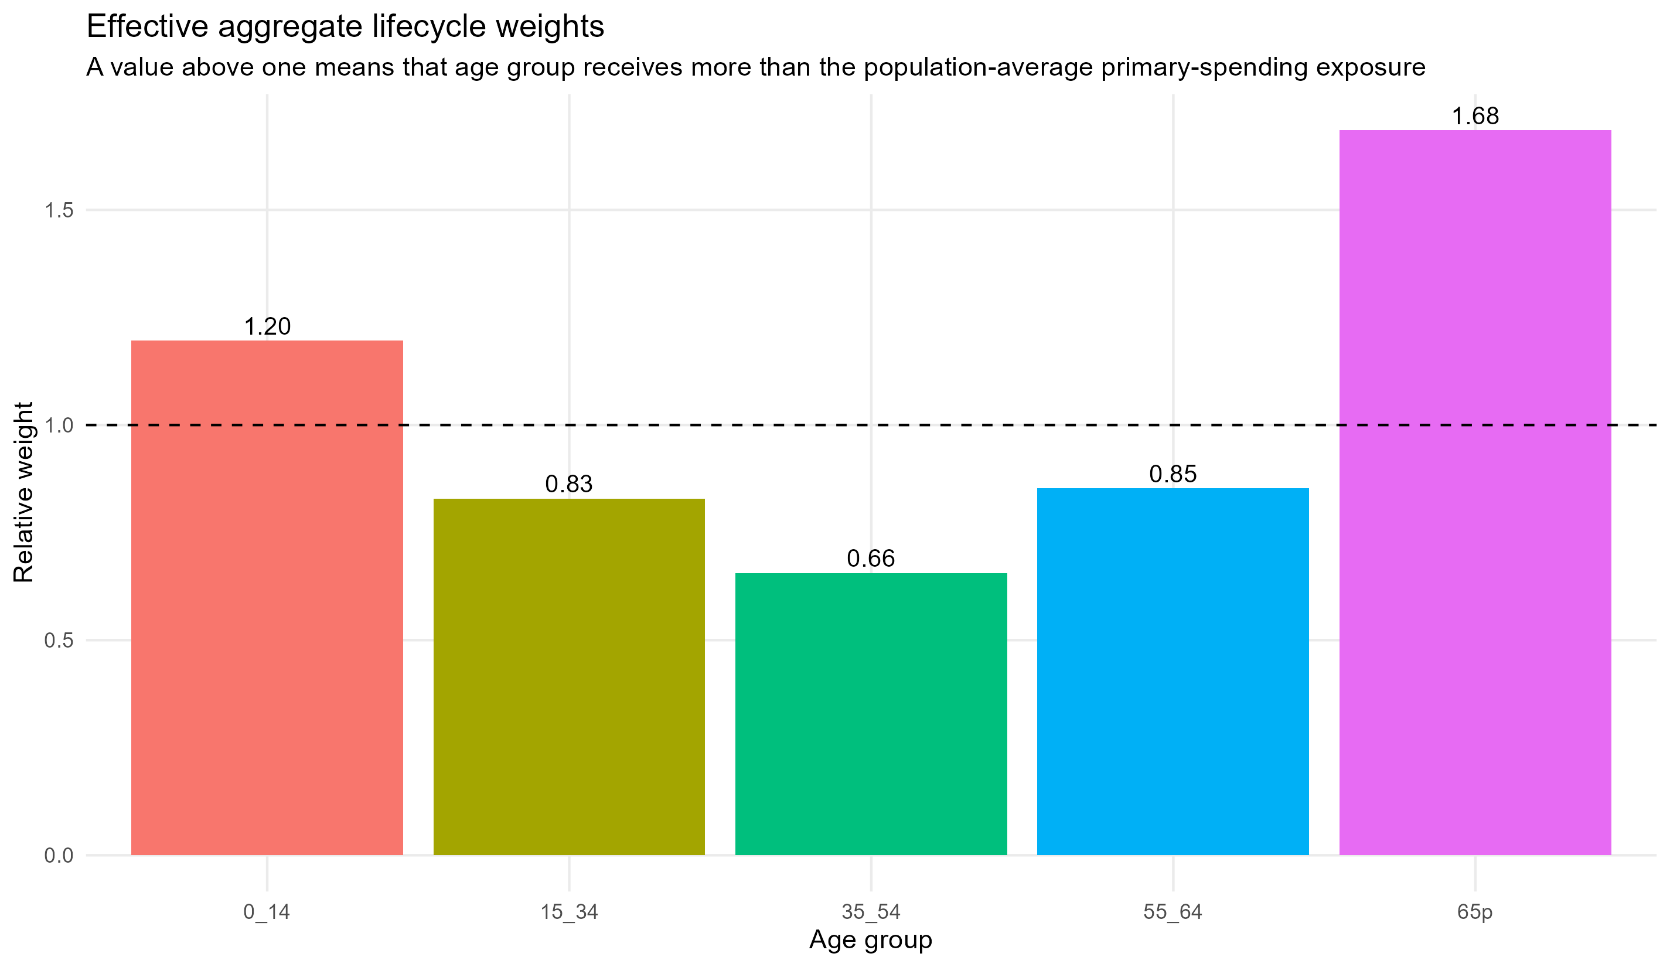
Effective lifecycle weights after combining purpose shares and within-purpose age profiles.

Evidence versus judgement
Input | Current basis | Assessment
Category expenditure shares | ABS GFS expenditure by purpose, FY2024-25, excluding interest from general public services | Observed evidence
Population age shares | Historical population data used by the existing model | Observed evidence
Projected age shares | Centre for Population 2025 Population Statement | Official projection
Within-category age relativities | Grouped proxy assumptions already used in the bottom-up model | Judgemental; direction is literature-consistent but magnitudes are not administrative estimates
Flat profile for other categories | Assumption that defence and remaining categories have no systematic lifecycle gradient | Judgemental
Fixed 2025 category mix | Laspeyres-type modelling choice | Transparent simplification
The construction is therefore partly evidence-based and partly conjectural. The expenditure shares and population paths are observed or official. The most influential uncertainty is the assumed within-category age-cost curve. The resulting effective weights - 1.20 for ages 0-14, 0.83 for 15-34, 0.66 for 35-54, 0.85 for 55-64 and 1.68 for 65+ - should be read as a transparent calibration. They should not be described as measured Australian incidence weights.

Implied demographic pressure
Year | Period | Profile index (2025=1) | Change from 2025 (%)
1,980 | Historical | 0.968 | -3.2
2,000 | Historical | 0.963 | -3.7
2,025 | Historical | 1.000 | 0.0
2,030 | Projection | 1.007 | 0.7
2,040 | Projection | 1.018 | 1.8
2,050 | Projection | 1.029 | 2.9
2,066 | Projection | 1.047 | 4.7
On the current population projections, the index rises from 1.000 in 2025 to 1.047 in 2066. Holding everything else fixed, the calibration therefore implies a 4.7% rise in age-weighted primary-spending exposure per person over the projection period.
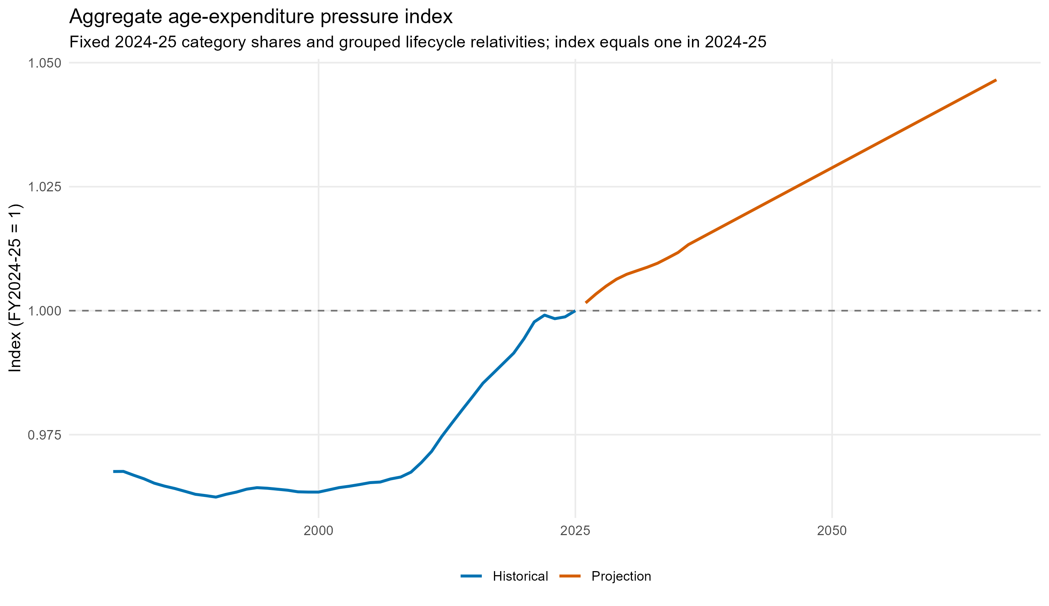
Historical and projected age-expenditure profile index, normalised to 2025.

Effect on the top-down estimates
Each model was re-estimated with the profile index replacing the separate youth and older-age shares; all non-demographic variables, COVID indicators, samples and forecast assumptions were held fixed. The ECM is unchanged because its validated candidate equation deliberately contains no demographic term.
Model | Demographics | Average rolling RMSE (pp) | 5-year RMSE (pp) | 2065-66, PBO anchored (% GDP)
ARIMAX (levels) | Age-expenditure profile index | 3.17 | 4.38 | 37.38
ARIMAX (levels) | Separate 0-14 and 65+ shares | 4.67 | 6.45 | 40.99
Differenced ARIMAX | Age-expenditure profile index | 3.32 | 4.67 | 35.25
Differenced ARIMAX | Separate 0-14 and 65+ shares | 3.49 | 5.00 | 34.67
Hybrid structural/macro | Age-expenditure profile index | 4.05 | 5.42 | 38.03
Hybrid structural/macro | Separate 0-14 and 65+ shares | 4.44 | 6.13 | 39.28
Structural OLS (levels) | Age-expenditure profile index | 3.51 | 4.42 | 40.60
Structural OLS (levels) | Separate 0-14 and 65+ shares | 4.89 | 6.68 | 39.88
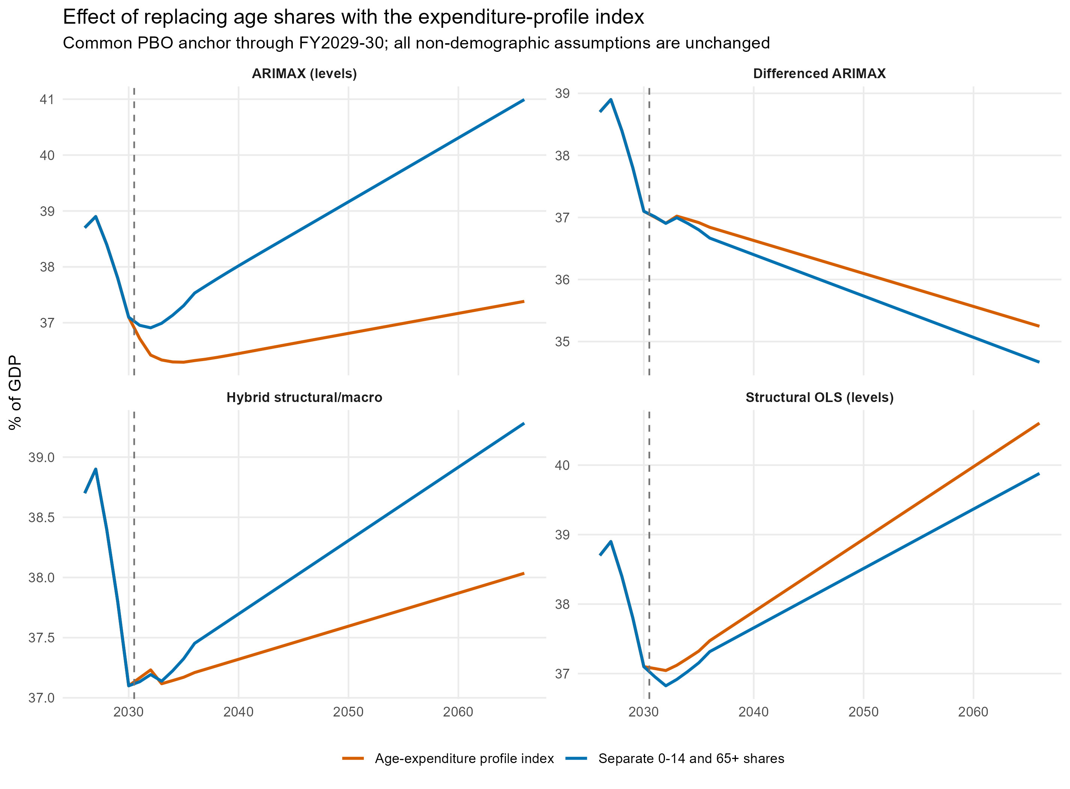
Matched PBO-anchored projections using separate age shares or the profile index.
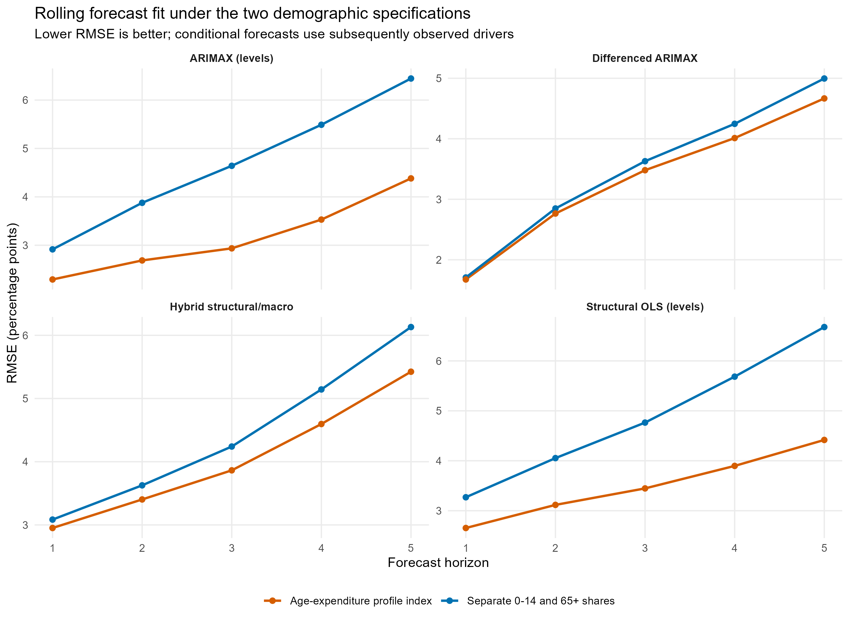
Rolling conditional forecast errors under the two demographic treatments.
The profile materially improves rolling fit for the levels ARIMAX and structural OLS and produces a smaller improvement for the hybrid and differenced ARIMAX. For the differenced ARIMAX, average rolling RMSE falls from 3.49 to 3.32 percentage points, and the PBO-anchored 2065-66 endpoint rises from 34.67% to 35.25% of GDP.
The coefficient evidence remains mixed. The profile coefficient is positive in the structural OLS, levels ARIMAX and hybrid structural block, but negative in the differenced ARIMAX. That negative change coefficient means the profile option does not resolve the weak identification of ageing effects in annual aggregate changes. Better fit alone is not enough to prefer a constructed index whose internal weights are partly imposed.
Model | Term | Estimate
Structural OLS (levels) | age_expenditure_profile | 0.942
ARIMAX (levels) | age_expenditure_profile | 0.323
Differenced ARIMAX | d_age_expenditure_profile | -0.480
Hybrid structural component | age_expenditure_profile | 0.248

How this relates to the literature
There are genuine empirical applications of age-expenditure profiles. Australian Treasury Intergenerational Reports multiply age-specific spending rates by projected populations for health, education and payments; health profiles draw on administrative program data and may distinguish decedents from non-decedents. The NSW Intergenerational Report uses static and dynamic age-cost indices. The Productivity Commission has embedded age-gender health and education expenditure profiles in a computable general equilibrium model. The European Commission's Ageing Report applies age- and sex-specific per-capita expenditure profiles to population projections.
Those applications normally use profiles as direct accounting inputs or within structural simulation models. In aggregate single-country time-series equations, researchers more commonly include elderly and youth shares, dependency ratios or the working-age share. The two methods answer different questions: shares allow the historical data to estimate separate aggregate associations, whereas a profile index imposes the lifecycle shape before estimation. For this project, age shares are therefore the more defensible headline top-down specification; the profile is a useful sensitivity and the natural framework for the bottom-up exercise.

What would make the profile evidence-based
Replace the proxy r_ka values with Australian per-person profiles derived from administrative or survey sources: Medicare and AIHW health spending by age and sex; Department of Education enrolments and expenditure per student; and DSS payment-recipient and outlay data by age and payment type. Map those profiles to the GFS purpose categories, document the reference year and population denominator, and test static versus gradually shifting health profiles. Until that work is complete, retain the option as a sensitivity and report the full weight audit alongside any result.

Sources

1. ABS Government Finance Statistics, Annual, 2024-25
Observed expenditure-by-purpose weights used in the index.
https://www.abs.gov.au/statistics/economy/government/government-finance-statistics-annual/2024-25

2. Centre for Population, 2025 Population Statement
Official projected age structure used by the model.
https://population.gov.au/publications/statements/2025-population-statement

3. Australian Treasury, 2007 Intergenerational Report - detailed methodology
Australian application of age-specific spending rates to projected populations, including health and education methods.
https://treasury.gov.au/publication/intergenerational-report-2007-2/appendix-c-detailed-methodology-and-assumptions

4. Australian Treasury, 2023 Intergenerational Report
Recent Australian application and source discussion for health age-cost profiles.
https://treasury.gov.au/sites/default/files/2023-08/p2023-435150.pdf

5. NSW Treasury, 2021 Intergenerational Report technical note
Application of static and dynamic age-cost indices.
https://www.treasury.nsw.gov.au/sites/default/files/2021-06/2021%20NSW%20IGR%20-%20Technical%20Note%20and%20Sensitivity%20Tables.pdf

6. Productivity Commission, Migrant Intake into Australia - technical supplement
Age-gender expenditure profiles embedded in an Australian economy-wide model.
https://assets.pc.gov.au/inquiries/completed/migrant-intake/draft/migrant-intake-draft-supplementa.pdf

7. European Commission, 2024 Ageing Report methodology
Official projection method combining age-sex spending profiles with population projections.
https://economy-finance.ec.europa.eu/system/files/2023-11/ip257_en_1.pdf

8. New Zealand Treasury Working Paper 03/15
Discussion of age-specific expenditure projections and age-share treatments in aggregate models.
https://www.treasury.govt.nz/publications/wp/modelling-effect-population-ageing-government-social-expenditures-wp-03-15

